

Cycle Shelter Locations

**South Campus**

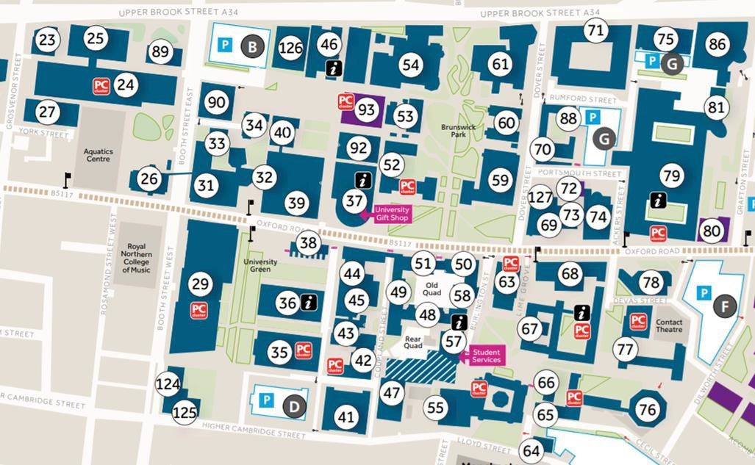

Between the Roscoe

and Williamson

Buildings

On Bridgeford Street,

near the Arthur Lewis Building

At the side of the Alan Gilbert Learning Commons Building on Lime Grove

Within Booth Street West multi-storey car park (entrance on the North side)

At the side of the Stopford Building on Ackers Street

At the rear of the Stopford Building

MECD Active Travel Hub

Outside the

Chemistry Building

Near the Aquatics Car Park, off Booth Street East



Cycle Shelter Locations

**North Campus**

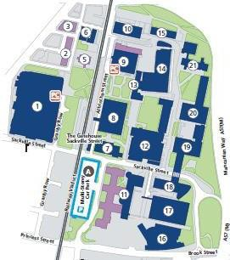

Outside the George Begg Building